**PROJECT TITLE :**

**DESIGN AND IMPLEMENTION OF AN IBM CLOUD IMAGE RECOGNITION**

**Phase 2**

**Innovation - Transforming Design into Solutions**

In this phase, we will outline the steps and strategies to put our initial design concept into action. Our goal is to create a solution that effectively addresses the problem we identified in the previous phase. Additionally, we will consider incorporating sentiment analysis to generate captions that capture the emotions and mood of the images as an innovative aspect of our solution.

Table of Contents

*Introduction*

Brief overview of the problem statement and the proposed design solution.

*Step 1: Design Refinement*

Review and refine the initial design concept based on feedback and additional research.

*Step 2: Technology Selection*

Choose appropriate technologies and tools to implement the design.

*Step 3: Data Collection and Preparation*

Gather necessary data and preprocess it for analysis and model training.

*Step 4: Sentiment Analysis Integration*

Explain how sentiment analysis will be incorporated into our solution.

*Step 5: Solution Development*

Describe the development process, including coding, testing, and iterations.

*Step 6: User Interface Desig*

Create an intuitive and user-friendly interface for our solution.

*Step 7: Testing and Validation*

Detail the testing methods and validation criteria.

*Step 8: Deployment*

Plan for deploying the solution and making it accessible to users.

*Step 9: Monitoring and Maintenance*

Outline strategies for ongoing monitoring, maintenance, and updates.

Conclusion

Summarize the key steps and innovations of this phase.

*Introduction*

In this phase, we will transform our initial design concept into a practical solution to address the identified problem. Our design concept involves using sentiment analysis to generate captions that capture the emotions and mood of images, enhancing user experience and engagement.

* *Design Refinement*

Based on feedback from stakeholders and further research, we will refine the design concept to ensure it aligns with the problem statement and user needs. This may involve adjusting the scope, features, or user requirements.

* *Technology Selection*

Select the appropriate technologies and tools required for implementing the solution. This may include choosing a programming language, framework, and sentiment analysis API/library.

* *Data Collection and Preparation*

Collect and preprocess the necessary data, including image datasets and textual data for sentiment analysis. Data cleaning, labeling, and augmentation may be necessary.

* *Sentiment Analysis Integration*

Explain how sentiment analysis will be incorporated into our solution. This includes selecting the sentiment analysis model, integrating it with image analysis, and generating relevant captions based on the emotions and mood detected.

* *Solution Development*

Develop the solution according to the refined design. This includes coding the backend logic, integrating the sentiment analysis module, and building a user interface (if applicable). Regular testing and iterations are crucial during this phase.

* *User Interface Design*

If the solution includes a user interface, design it to be intuitive and user-friendly. Ensure that users can easily interact with the application and view the generated captions alongside images.

* *Testing and Validation*

Perform rigorous testing to ensure the solution functions correctly. Validate the accuracy of sentiment analysis and caption generation. Address any bugs or issues that arise during testing.

* *Deployment*

Plan for the deployment of the solution to make it accessible to users. This may involve selecting a hosting platform, setting up databases, and configuring security measures.

* *Monitoring and Maintenance*

Implement strategies for ongoing monitoring and maintenance of the solution. Regularly update sentiment analysis models and address any issues or user feedback. Consider adding new features based on user needs.

* *Conclusion*

In this phase, we have outlined the comprehensive steps to transform our initial design concept into an innovative solution that incorporates sentiment analysis for generating image captions. This solution aims to effectively address the problem identified in the previous phase while enhancing user experience by capturing the emotions and mood of images.

***ABSTRACT***

People are actively expressing their views and opinions via the use of visual pictures and text captions on social media platforms, rather than just publishing them in plain text as a consequence of technical improvements in this field. With the advent of visual media such as images, videos, and GIFs, research on the subject of sentiment analysis has expanded to encompass the study of social interaction and opinion prediction via the use of visuals.

***RELATED WORK***

They conducted a study in which they evaluated three different Twitter sentiment analysis algorithms using three distinct metrics: pixels, stream, and themes (PST), according to the authors of . To extract, map, and analyze user comments on an online product, the information acquired was put to use, and the findings were made available to the general public. A greater amount of attention was paid to negative factors as well as influencing variables than had been paid to them before . When it comes to the analysis of the essential characteristics, there are no details, which represents a huge gap in our inquiry

PROPOSED METHODOLOGY

It is intended that the design of this investigation be divided into four major stages, which are as follows

* Data preprocessing and preparation
* Possibility of feature extraction
* Developing and extracting views and information
* Classification of points of view

The data that are obtained from the web content are not appropriately formatted at the time of extraction. The first step prepares the data in preparation for the sentiment analysis and extraction to take place later on. Users' opinions in product evaluations are mined for product attributes using opinion mining as one possible method of discovering and matching up to the power and scarcity of things.

DATA PREPROCESSING

The initial phases of the project include gathering data from many online publications that will be used as inputs for the proposed technique. The inadequately structured or not structured data sources are collected, and they may be used for data processing and data storage in addition to being used for data collection .

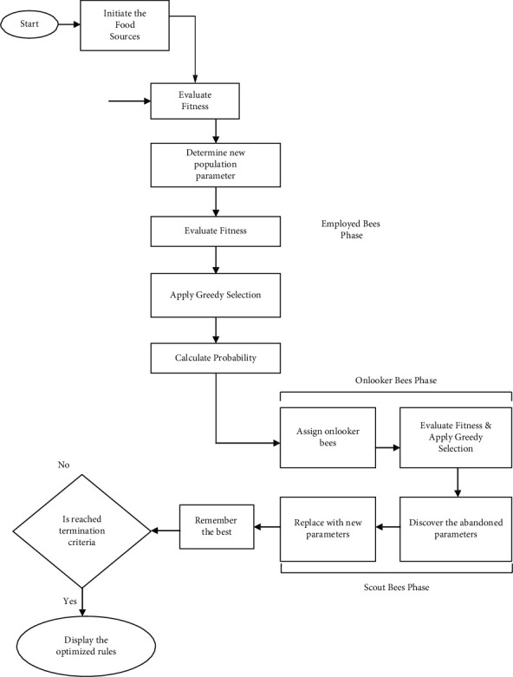

CLASSIFICATION OF OPPINION

This phase is required for the organization of reviews that include three different sorts of product opinions. A method of classification known as the ID3 algorithm may do this. It is one of many

classification algorithms available. It is possible to categorize reviews into three categories: good, negative, and neutral, depending on the organization that organizes the opinions. These three categories are related to different points of view

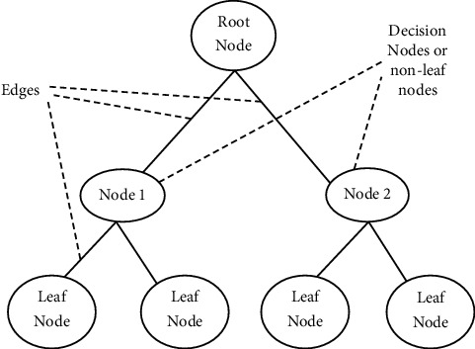

RESULTS AND DICUSSION

The outcome of the suggested implementation is shown and discussed in depth in this section, which includes the findings of experimentation.To assess the efficacy of opinion mining systems and to explain both the hypothetical and real evolution of these systems, an evaluation metric is developed and used. It consists of a set of measurements that are trailing behind the overall assessment approach that has not been released. Recall, precision, and the F-measure are just a few of the metrics that have been used for assessment and testing. It is necessary to compute the values of these measures to make better use of this suggested approach for the efficient categorization of reviews using mining to make better use of it

According to the review classification chosen, the values of measures are calculated in

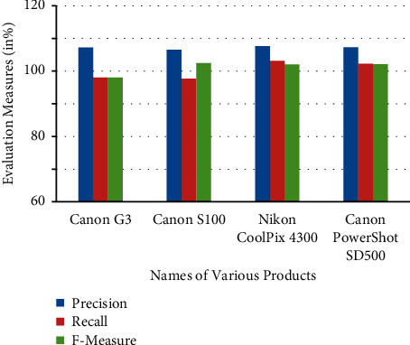

CONCLUSION

In this research endeavor, the DLBI technique for opinion mining is described in great depth in detail. The overall performance of DLBI was evaluated based on the product reviews collected. Precision, recall, accuracy, and the F-Measure were determined for each of these assessments and then compared to one another to see which was the most accurate. Additionally, the findings of the comparison of existing procedures with DLBI, as well as the accuracy values connected with each method, are presented in this proposed work.

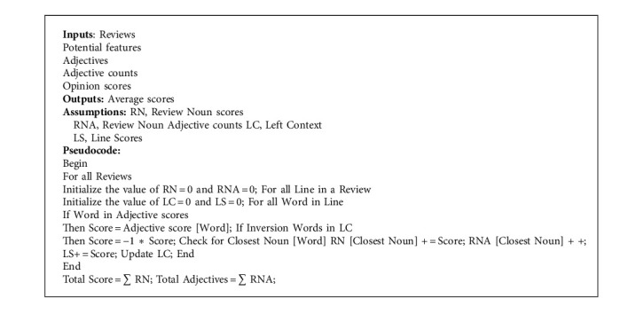

The average utilization of both DLBI and ID3 is shown, indicating the efficacy of both techniques. The work outlined in this proposal contributes to the improvement of the process of opinion mining and classification. Two additional contemporary algorithms, J48 and Bagging of state-of-the-art works, reach accuracy values of just 88.51 percent and 87.5 percent, respectively, when compared to the accuracy value.